Willwara Arachchilage Shamle Imal Thilaksiri

Configuring a network using Packet tracer

# Introduction

The assignment is to study and understand network technologies and services by looking at them in layers and following established network standards. (Shacklett et al., 2021)

We use the TCP/IP or OSI model to understand how network protocols work together establishing communication between networked devices.

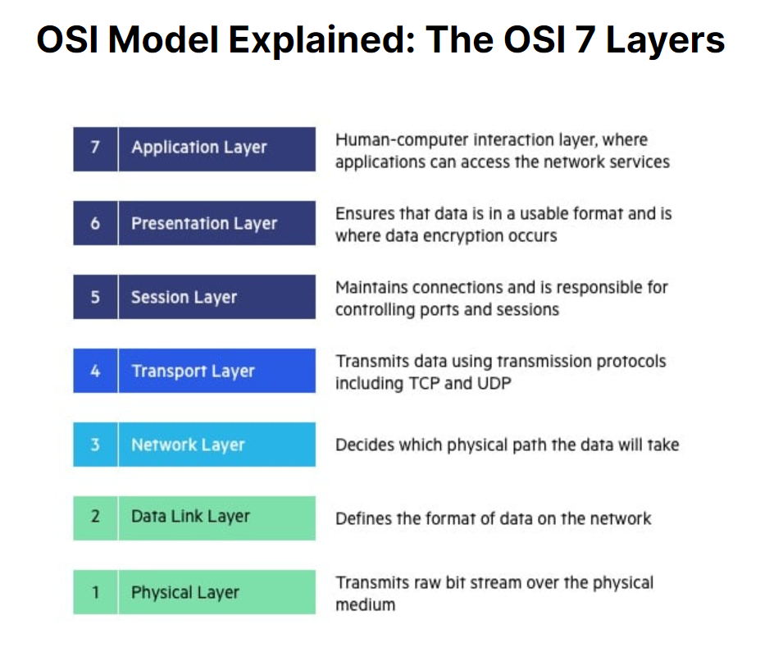In this project we will understadn the flow of data packets, establishing the connection between devices in a network topology

(Richardson, 2023)

# Task 1

The network topology is constructed with the help of routers, switches, and computers (nodes). Each component is connected by the routers using a switch, several subnets have been established at the ease of a DHCP pool namely:

* B1L2
* B1L1
* B2L2
* B2L1

Switches are used to provide the Ip addresses for the end-nodes which are in-turn connected to the router. Hence the router is configured first, each router has been set up in a specific way.

1. Select the required port which the router has been connected to with the switch (usually FastEthernet port)
2. Configure using CLI
3. Use of ‘No shut’ to bring the connection up
4. Addition of an ip address using ‘ip add ######’
5. Separate the pool of devices using ‘ip dhcp pool (B1L1)’
6. Provide network address same as the ip address
7. Provide DNS-server address same as the ip address
8. Provide Default-router address same as the ip address
9. After the configuration is finished, hover over to view the established connections between device ports.

Pinging is useful to ensure configuration is handled correctly. IP configuration for each router is necessary, therefore the above steps should be applied on each router.

The address ranges for the 4 pools vary between 2 subnet masks.

* Network 172.16.0.0 /24
* Network 172.16.1.0 /24
* Network 192.168.0.128 /25
* Network 192.168.0.0 /25

|  |  |  |  |  |  |  |
| --- | --- | --- | --- | --- | --- | --- |
| Network labels | Subnet mask | “ip add” | “ip DHCP pool” | “network” | “default-router” | “dns-server” |
| 172.16.0.0 /24 (pink) | 255.255.255.0 | 172.16.0.1 | B1L2 | 172.16.0.0 | 172.16.0.1 | 172.16.0.1 |
| 172.16.1.0 /24 (yellow) | 255.255.255.0 | 172.16.1.1 | B1L1 | 172.16.1.0 | 172.16.1.1 | 172.16.1.1 |
| 192.168.0.128 /25 (green) | 255.255.255.128 | 192.168.0.129 | B2L2 | 192.168.0.128 | 192.168.0.129 | 192.168.0.129 |
| 192.168.0.0 /25 (blue) | 255.255.255.128 | 192.168.0.1 | B2L1 | 192.168.0.0 | 192.168.0.1 | 192.168.0.1 |

1. Subnet Mask & IP address range
2. Subnet mask 24

* The default subnet mask for a class C network is 255.255.255.0, indicating that all IP addresses within the range of 192.0.0.0 to 223.255.255.0 belong to this subnet. (*/24 Subnet Mask*, 2023)
* Block size for this network is 256, hence the number of blocks is 1
* One big block utilizes all 256 addresses.

1. Subnet mask 25
   * Subnetting involves creating 25 subnets by dividing the various default addresses in Class A, B, and C.
   * This subnet mask creates two subnets. For instance, with an IP range like 193.168.1.0 to 193.168.1.255, each subnet range accommodates 128 IPs. Out of these, 126 IPs are available for hosts, with the first and last addresses reserved for network ID and broadcast, respectively. (*25 Subnet*, 2023)
   * Block size for this network is 128, hence the number of block is 2
   * Two blocks are issued utilizing 128 addresses each

2) Default gateway

* Default router or gateways ensure seamless data flow between devices within a network and the broader digital environment.
* IP address for default-router has been configured with the first ip address given to the network. (PowerCert Animated Videos, 2021)
* 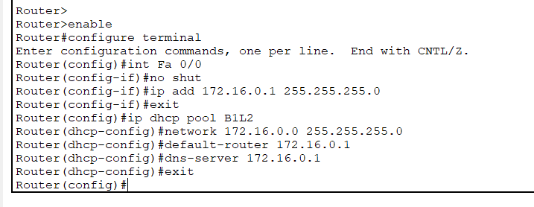Such that the network ip is 172.16.0.1 255.255.255.0

3) Routing Solution

* Routing between subnets uses a model where the contents of one router are forwarded to the next router using a basic method of forwarding packets.This had been configured on every router individually, the below example from my project on configuring the ip route (from Router1) to forward the contents to the next router (Router0)

Ex: ip-route 0.0.0.0 0.0.0.0 10.0.0.2

* Using 0.0.0.0 0.0.0.0 forwards all data to the next assigned router

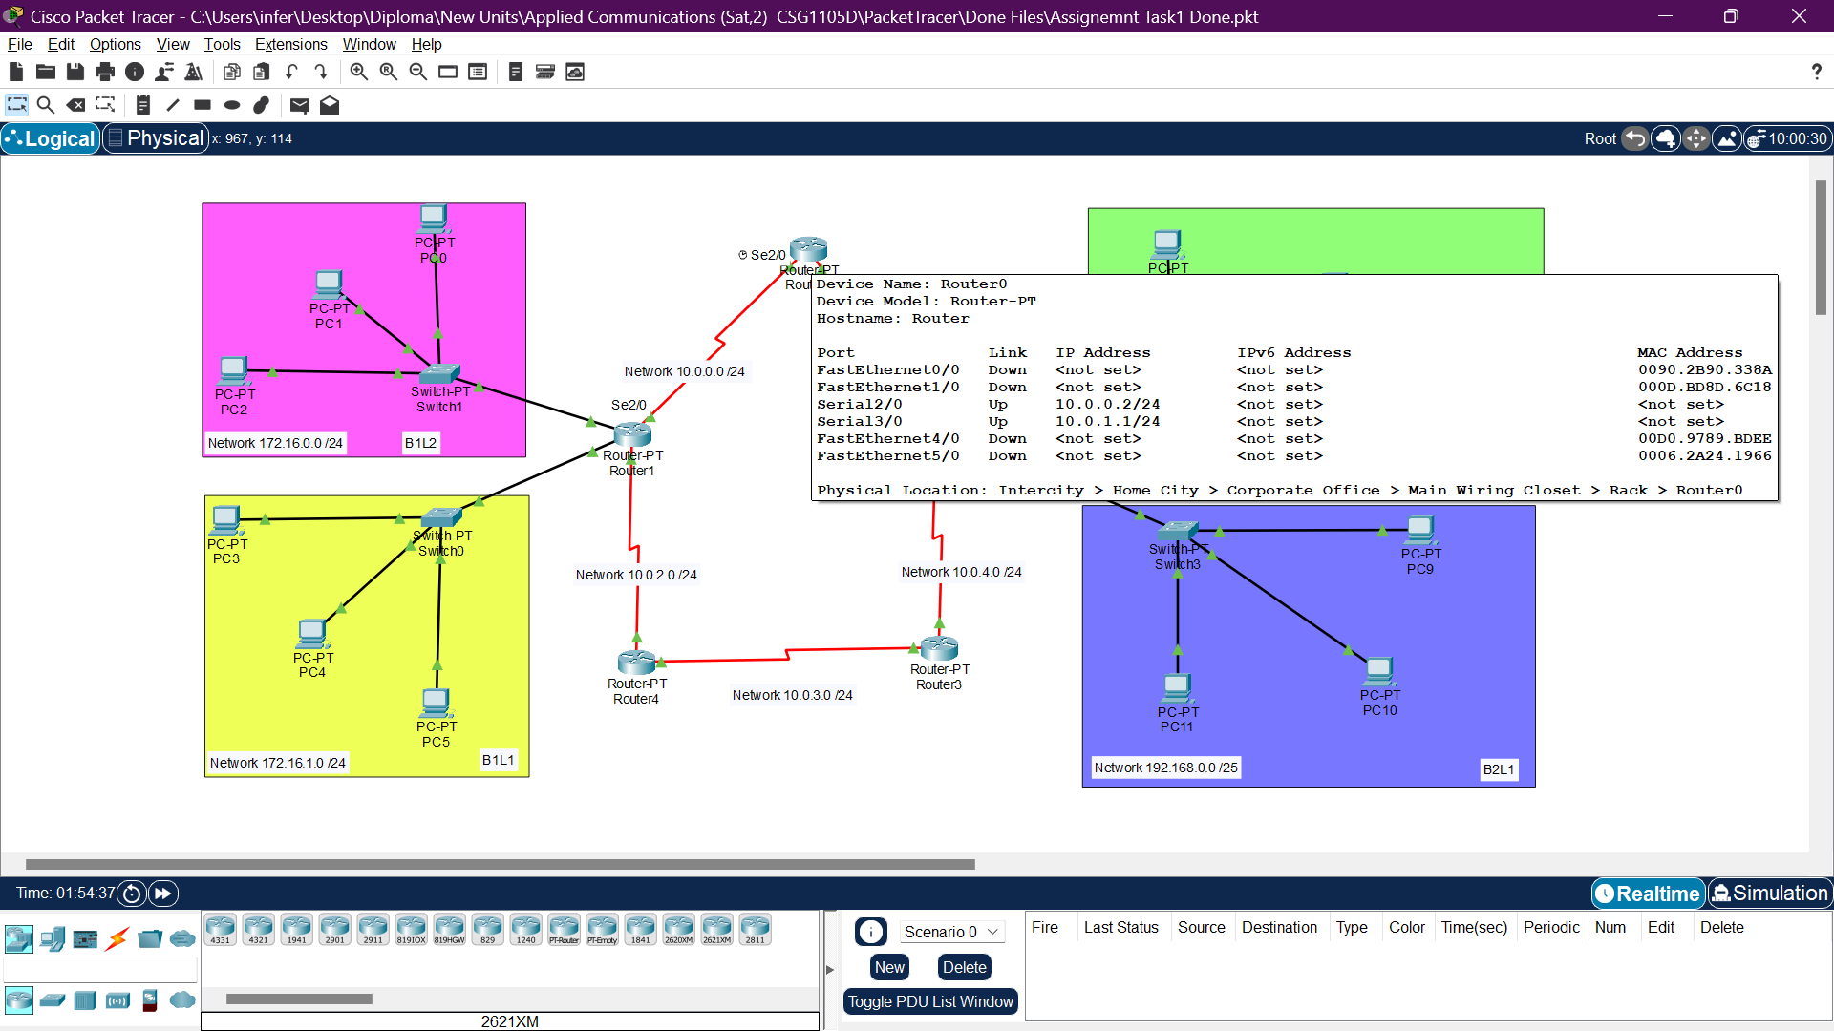

Pinging hosts from the same subnet

Pinging hosts from the different subnet

# Task 2

A core switch is used to manipulate the flow of the data to the even and odd nodes available in B2L2 (green) and B2L1 (blue) networks.

Management intends to introduce a VLAN solution to enable adaptable seating arrangements for the staff. Therefore, the model should modified adapting to this change.

* The even numbered PC’s under VLAN 100 - 192.168.128.0 /25
* The odd numbered PC’s under VLAN 200 - 192.168.0.0/25

We will implement the Router on a stick model to configure our network topology.

In the router-on-a-stick model, the router's interface is divided into sub-interfaces, each serving as the default gateway for its respective VLAN. This setup efficiently manages VLANs on the same physical interface, promoting effective network segmentation. (GeeksforGeeks, 2021)

What is VLAN network ?

A VLAN (Virtual Local Area Network) is a virtual connection that links various devices and network points from different LANs into a single logical network. (*What Is VLAN (Virtual LAN)? - IT Glossary | SolarWinds*, n.d.)

**Process**

1. Inclusion of an additional switch is required to implement router on a stick model

Firstly we will create VLAN 100 and VLAN 200 on the 3 switches using CLI (switch in config mode)

*Switch>*

*Switch>enable*

*Switch#configure terminal*

*Switch(config)# vlan 200*

*Switch(config-vlan)# name ODD*

*Switch>*

*Switch>enable*

*Switch#configure terminal*

*Switch(config)# vlan 100*

*Switch(config-vlan)# name EVEN*

1. The 2 switches excluding the core switch should be configured, to ensure the correct Vlans and tied with the appropriate computer numbers.

ODD – PC 7,9,11 | EVEN – PC 6,8,10

* Access Switch2 and Switch3 in configuration mode, access the interface of ports to which the nodes are connected to using the CLI
* Using this code we can configure the nodes to intercept Vlan 100 or Vlan 200 accordingly
* A screenshot of a computer

  Description automatically generated*switchport*

*Switch>*

*Switch>enable*

*Switch#configure terminal*

*Enter configuration commands, one per line. End with CNTL/Z.*

*Switch(config)#int Fa 0/1*

*Switch(config-if)#switchport mode access*

*Switch(config-if)#switchport access vlan 100*

*Switch(config-if)#exit*

*Switch(config)#exit*

*Switch#*

1. Configuring the interface between router and core switch

* Assign one interface to vlan 100 the other to vlan 200 using switchport

*Switch>enable*

*Switch#configure terminal*

*Enter configuration commands, one per line. End with CNTL/Z.*

*Switch(config)#interface Fa 2/1*

*Switch(config-if)#switchport mode access*

*Switch(config-if)#switchport access vlan 100*

*Switch(config-if)#exit*

*Switch(config)#interface Fa 3/1*

*Switch(config-if)#switchport mode access*

*Switch(config-if)#switchport access vlan 200*

*Switch(config-if)#exit*

*Switch(config)#exit*

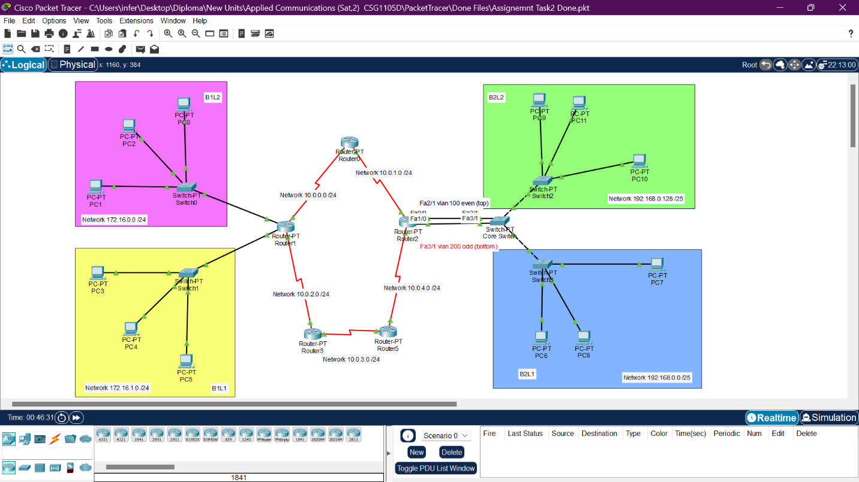

1. Configure the switches that branch out from the core switch using switchport trunk

*Switch>*

*Switch>enable*

*Switch#configure terminal*

*Enter configuration commands, one per line. End with CNTL/Z.*

*Switch(config)#interface Fa 0/1*

*Switch(config-if)#switchport mode trunk*

*Switch(config-if)#exit*

*Switch(config)#exit*

Pinging from pc 10 (green) to pc 3 (yellow)

# Task 3

|  |  |  |  |  |
| --- | --- | --- | --- | --- |
| Information | Source IP | Destination IP | Source MAC address | Destination MAC address |

A packet contains details as such.

* Layer 2 address (data link layer) are MAC addresses (Media Access Control Addresses) that are burnt onto the NIC during manufactory.
* Layer 3 addresses (network layer) are IP addresses (Internet Protocol) that tend to change from one network to another.

Let's talk about the pink and green subnets. Imagine data packets moving through a router – the MAC addresses usually stay the same because they're tied to the physical network cards. However, the IP addresses (like home addresses for devices) might change. At the router, the starting IP address is often swapped with the router's address when coming in, and the destination IP address is updated to match the target device when going out.

This is similar to what happens when we ping a famous company site such as Facebook. Numerous servers are used to manage the data traffic, but we can only see the ip address of the closest router to our range.

We can further understand this using task 2 where an extra switch has been used in comparison to task 1. The source IP address on the incoming side may be replaced with the router's IP address, and the destination IP address on the outgoing side may be updated to match the IP address of the target device within the specific VLAN. As a result, the VLAN introduces an additional layer of addressing.

This process of translating addresses is crucial for guiding data between different subnets. The router functions as a gateway, steering traffic from one subnet to another.

Adjusting Layer 3 addresses ensures that data finds its way to the correct destination within the target subnet. These changes are necessary to uphold distinct addressing within each subnet and facilitate smooth communication among devices across varied network segments. The simulation mode available in Cisco Packet Tracer helps us better understand the flow of data including the spanning tree protocols and the rest of protocols, which are necessary when communicating between devices in a network.

(*Layer 2 Vs. Layer 3 Addressing*, 2019)

# References

*/24 subnet mask*. (2023, February 15). Packet Tracer Labs. <https://www.packettracerlab.com/24-subnet-mask/#:~:text=%2F24%20subnet%20mask%20is%20the,255.0>.

*25 subnet*. (2023, September 21). Packet Tracer Labs. <https://www.packettracerlab.com/25-subnet/#:~:text=%2F25%20subnet%20is%20obtained%20through,%2C%20b%2C%20and%20c%20addresses.&text=In%20one%20subnet%20range%2C%20we,reserved%20as%20a%20broadcast%20address>.

PowerCert Animated Videos. (2021, July 26). *Default Gateway explained* [Video]. YouTube. <https://www.youtube.com/watch?v=pCcJFdYNamc>

Shacklett, M. E., Novotny, A., & Gerwig, K. (2021, July 13). *TCP/IP*. Networking. <https://www.techtarget.com/searchnetworking/definition/TCP-IP>

Richardson, L. (2023, December 21). *What is OSI Model | 7 Layers Explained | Imperva*. Learning Center. <https://www.imperva.com/learn/application-security/osi-model/>

GeeksforGeeks. (2021, October 25). *Configuration of Router on a stick*. <https://www.geeksforgeeks.org/configuration-of-router-on-a-stick/>

*Layer 2 vs. Layer 3 addressing*. (2019, March 9). <https://community.cisco.com/t5/security-knowledge-base/layer-2-vs-layer-3-addressing/ta-p/3123440#:~:text=The%20IP%20address%20is%20a,%2C%20IPX%2C%20or%20Appletalk>).

*What is VLAN (Virtual LAN)? - IT Glossary | SolarWinds*. (n.d.). <https://www.solarwinds.com/resources/it-glossary/vlan>